Data in Memory
# Source: AI Source: Provided by: [Data Path: Persons Table -> ID Column: 1, Name_En Column: Motasem Essam] -> From: [Chatgpt (GPT‑5 Mini)] on [12/10/2025]
Data in memory is how computers store and organize information inside RAM or cache while programs are running.

Data in Memory – Definition
# Source: AI Source: Provided by: [Data Path: Persons Table -> ID Column: 1, Name_En Column: Motasem Essam] -> From: [Chatgpt (GPT‑5 Mini)] on [12/10/2025]
Data in memory = information temporarily stored in a computer’s RAM or cache so it can be quickly accessed and processed by the CPU.
- Memory stores everything a program needs while running: numbers, text, images, instructions, etc.
- Once the computer is turned off, RAM loses data (volatile memory), but other storage (like hard drives) keeps data permanently.

How Data is Represented in Memory
# Source: AI Source: Provided by: [Data Path: Persons Table -> ID Column: 1, Name_En Column: Motasem Essam] -> From: [Chatgpt (GPT‑5 Mini)] on [12/10/2025]
All data in memory is ultimately represented in binary format (0s and 1s), because computers work using electrical signals (on/off).

A. Primitive Data Types
# Source: AI Source: Provided by: [Data Path: Persons Table -> ID Column: 1, Name_En Column: Motasem Essam] -> From: [Chatgpt (GPT‑5 Mini)] on [12/10/2025]
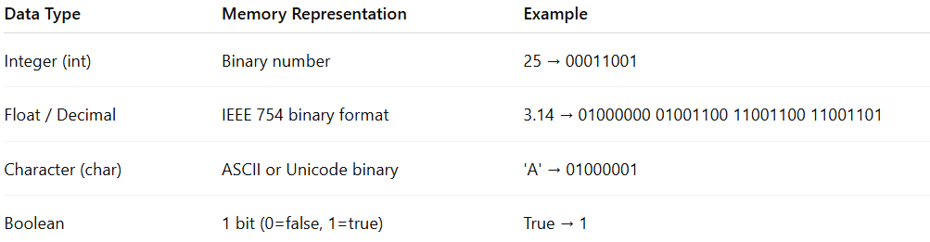
Data Type | Memory Representation | Example
Integer (int) | Binary number | 25 → 00011001
Float / Decimal | IEEE 754 binary format | 3.14 → 01000000 01001100 11001100 11001101
Character (char) | ASCII or Unicode binary | 'A' → 01000001
Boolean | 1 bit (0=false, 1=true) | True → 1

B. Text / Strings
# Source: AI Source: Provided by: [Data Path: Persons Table -> ID Column: 1, Name_En Column: Motasem Essam] -> From: [Chatgpt (GPT‑5 Mini)] on [12/10/2025]
- Stored as a sequence of characters, each represented by ASCII or Unicode codes.
Example: "Hi"
- 'H' → 01001000
- 'i' → 01101001
- Stored consecutively in memory.

C. Complex Data Structures
# Source: AI Source: Provided by: [Data Path: Persons Table -> ID Column: 1, Name_En Column: Motasem Essam] -> From: [Chatgpt (GPT‑5 Mini)] on [12/10/2025]
- Data structures are a way to represent data in memory efficiently.
- They organize data in memory so programs can access, modify, and process it easily.
Examples:
- Array – Consecutive memory cells storing similar elements.
  - [10, 20, 30] → Stored as 3 binary integers in sequence.
- Object / Struct – Memory blocks storing multiple fields.
  - Example: Student object → ID, Name, Score
- Linked List / Tree / Graph – Data stored in nodes with pointers to other nodes, allowing flexible structures.
Data structures are essentially organized patterns of memory representation that allow programs to store and manipulate complex data efficiently.

Memory Organization
# Source: AI Source: Provided by: [Data Path: Persons Table -> ID Column: 1, Name_En Column: Motasem Essam] -> From: [Chatgpt (GPT‑5 Mini)] on [12/10/2025]
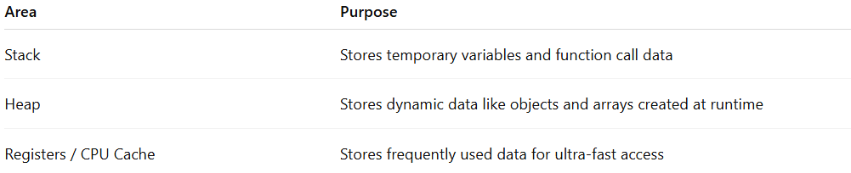
Area | Purpose
Stack | Stores temporary variables and function call data
Heap | Stores dynamic data like objects and arrays created at runtime
Registers / CPU Cache | Stores frequently used data for ultra-fast access

Example – Representing Data in Memory
# Source: AI Source: Provided by: [Data Path: Persons Table -> ID Column: 1, Name_En Column: Motasem Essam] -> From: [Chatgpt (GPT‑5 Mini)] on [12/10/2025]
Let’s say we have a student record:
ID = 1, Name = "Ali", Score = 85
Memory representation:
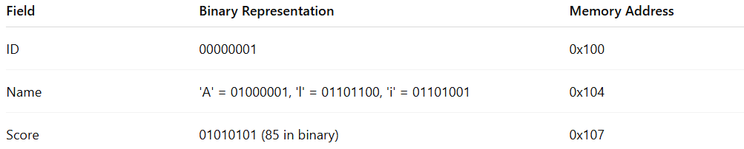
Field | Binary Representation | Memory Address
ID | 00000001 | 0x100
Name | 'A' = 01000001, 'l' = 01101100, 'i' = 01101001 | 0x104
Score | 01010101 (85 in binary) | 0x107
- Each piece of data has a specific memory location.
- Data structures like arrays or objects allow multiple related pieces of data to be stored together in an organized way.
- The CPU reads and writes these binary values during processing.

Key Points to Remember
# Source: AI Source: Provided by: [Data Path: Persons Table -> ID Column: 1, Name_En Column: Motasem Essam] -> From: [Chatgpt (GPT‑5 Mini)] on [12/10/2025]
- All data in memory is ultimately binary.
- Primitive types (int, char, float) have fixed binary formats.
- Complex types (arrays, objects, linked lists) are stored in blocks of memory, often using pointers.
- Memory is organized for fast access: stack, heap, or cache.
- Data structures are ways to represent and organize data in memory efficiently, making processing faster and easier.

Responsible for Converting Data to Binary
# Source: AI Source: Provided by: [Data Path: Persons Table -> ID Column: 1, Name_En Column: Motasem Essam] -> From: [Chatgpt (GPT‑5 Mini)] on [12/10/2025]
Computers store and process all information in binary form (0s and 1s). Several components in the computer system work together to convert human-readable data into binary and store it in memory.

1. Programming Languages and Compilers
# Source: AI Source: Provided by: [Data Path: Persons Table -> ID Column: 1, Name_En Column: Motasem Essam] -> From: [Chatgpt (GPT‑5 Mini)] on [12/10/2025]
When programmers write code using numbers, text, or variables, the compiler or interpreter converts this high-level code into machine code (binary instructions) that the computer can execute.
Example:
int x = 5;
The compiler converts this into binary instructions that the CPU understands.

2. Character Encoding Systems
# Source: AI Source: Provided by: [Data Path: Persons Table -> ID Column: 1, Name_En Column: Motasem Essam] -> From: [Chatgpt (GPT‑5 Mini)] on [12/10/2025]
Text characters must be converted into binary numbers before being stored in memory.
Common encoding systems include:
- ASCII (American Standard Code for Information Interchange)
Example:
'A' → 01000001
- Unicode
Used for representing characters from many languages.
These encoding systems assign binary numbers to characters so they can be stored and processed.

3. CPU (Central Processing Unit)
# Source: AI Source: Provided by: [Data Path: Persons Table -> ID Column: 1, Name_En Column: Motasem Essam] -> From: [Chatgpt (GPT‑5 Mini)] on [12/10/2025]
The CPU is responsible for executing instructions and processing binary data.
It:
- Reads binary instructions from memory.
- Performs arithmetic and logical operations.
- Moves binary data between registers, cache, and RAM.

4. Memory System (RAM and Cache)
# Source: AI Source: Provided by: [Data Path: Persons Table -> ID Column: 1, Name_En Column: Motasem Essam] -> From: [Chatgpt (GPT‑5 Mini)] on [12/10/2025]
Memory stores data after it has been converted to binary.
- RAM stores program data during execution.
- CPU Cache stores frequently used binary data for faster access.

5. Input Devices
# Source: AI Source: Provided by: [Data Path: Persons Table -> ID Column: 1, Name_En Column: Motasem Essam] -> From: [Chatgpt (GPT‑5 Mini)] on [12/10/2025]
Input devices also convert information into binary signals.
Examples:
- Keyboard → converts key presses into binary codes.
- Mouse → converts movement and clicks into binary signals.
- Scanner/Microphone → convert images or sound into digital binary data.

Summary
# Source: AI Source: Provided by: [Data Path: Persons Table -> ID Column: 1, Name_En Column: Motasem Essam] -> From: [Chatgpt (GPT‑5 Mini)] on [12/10/2025]
The conversion of data to binary involves several components:
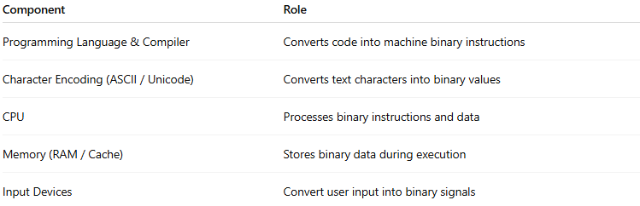
Component | Role
Programming Language & Compiler | Converts code into machine binary instructions
Character Encoding (ASCII / Unicode) | Converts text characters into binary values
CPU | Processes binary instructions and data
Memory (RAM / Cache) | Stores binary data during execution
Input Devices | Convert user input into binary signals

